**url_launcher:**

<https://pub.dev/packages/url_launcher>

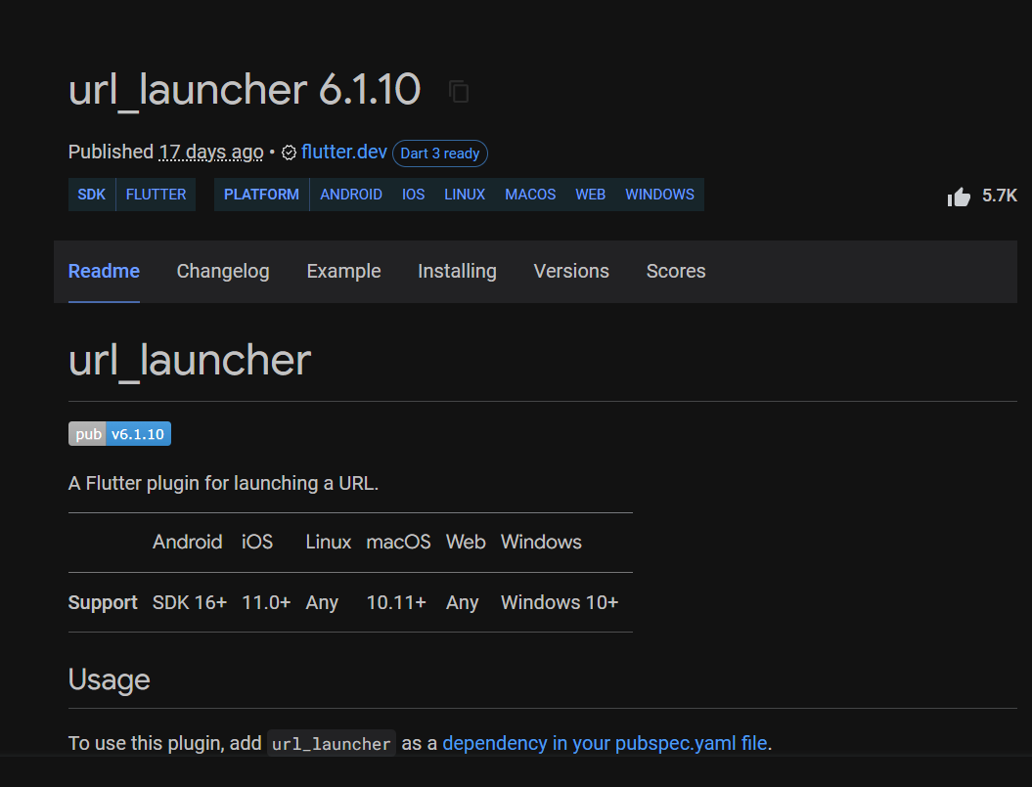

**http:**

<https://pub.dev/packages/http>

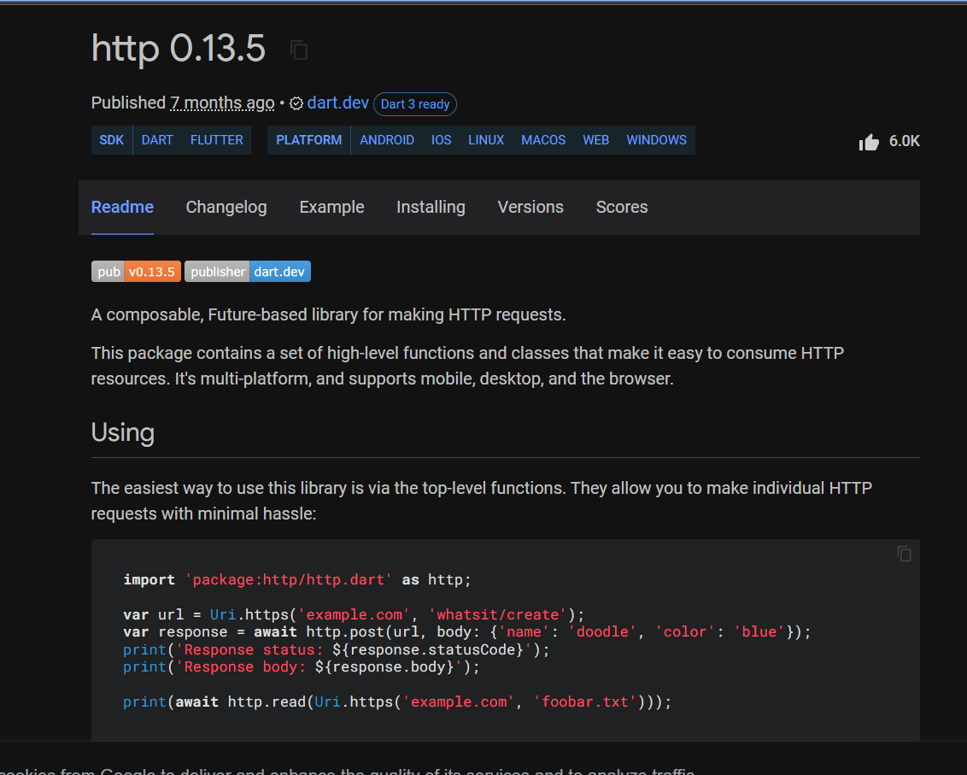

**Flutter phone direct caller:**

<https://pub.dev/packages/flutter_phone_direct_caller>

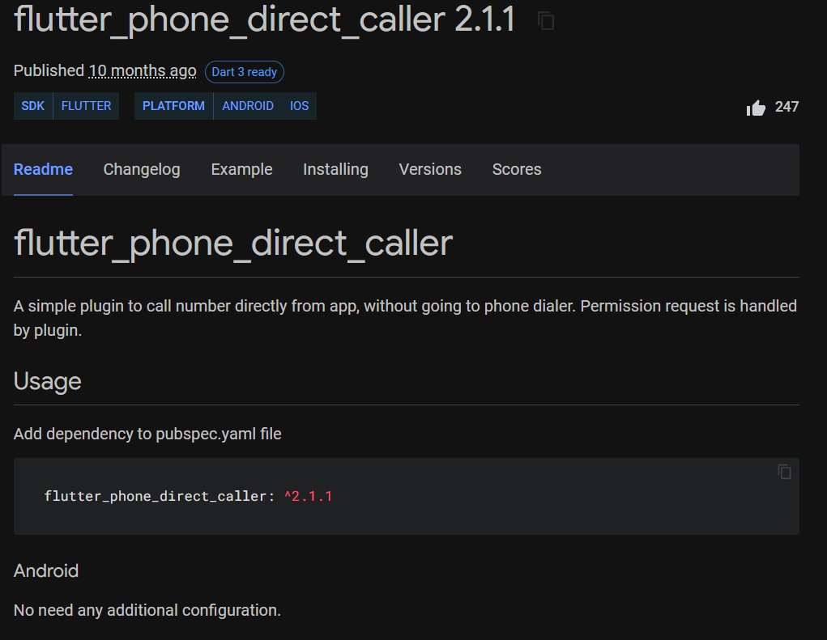

**Date time picker:**

<https://pub.dev/packages/date_picker_timeline/install>

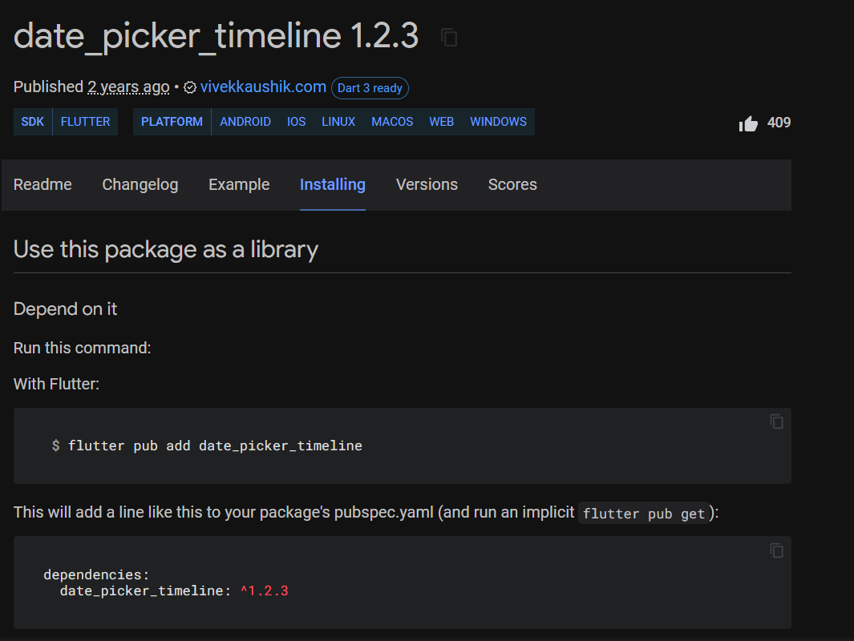

**Awesome Dialog box**

<https://pub.dev/packages/awesome_dialog/install>

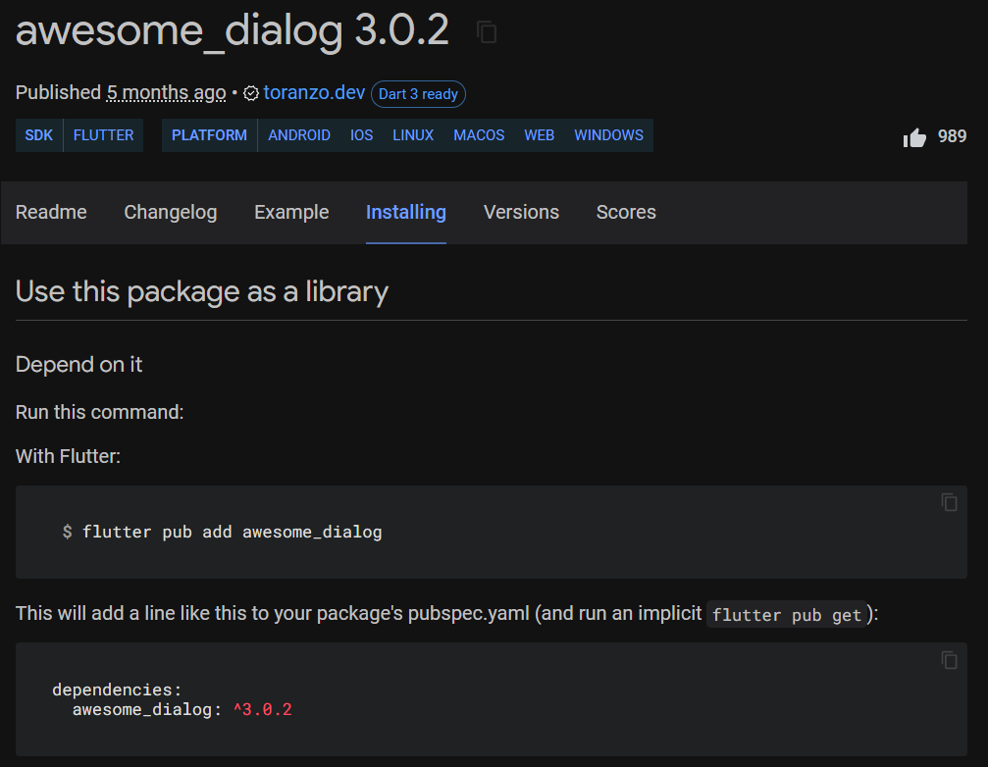

**Esewa_pnp:**

<https://pub.dev/packages/esewa_pnp/install>

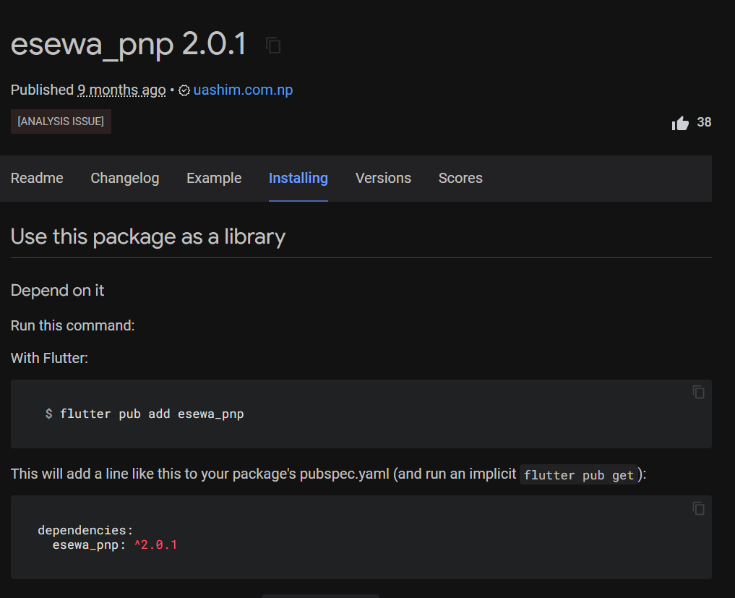

**Django serializer:**

[**https://www.django-rest-framework.org/api-guide/serializers/**](https://www.django-rest-framework.org/api-guide/serializers/)

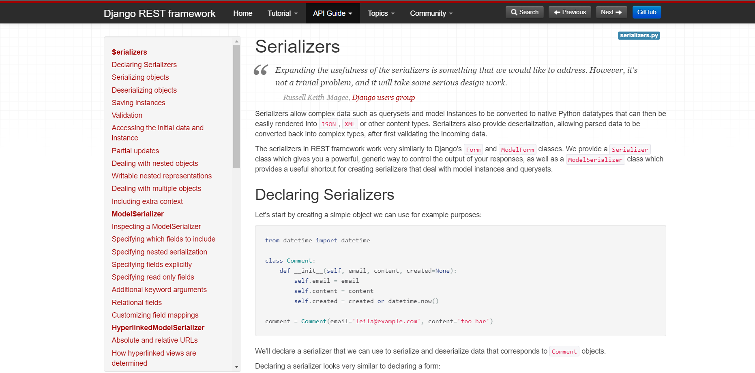

**Class based view:**

[**https://docs.djangoproject.com/en/4.1/topics/class-based-views/**](https://docs.djangoproject.com/en/4.1/topics/class-based-views/)

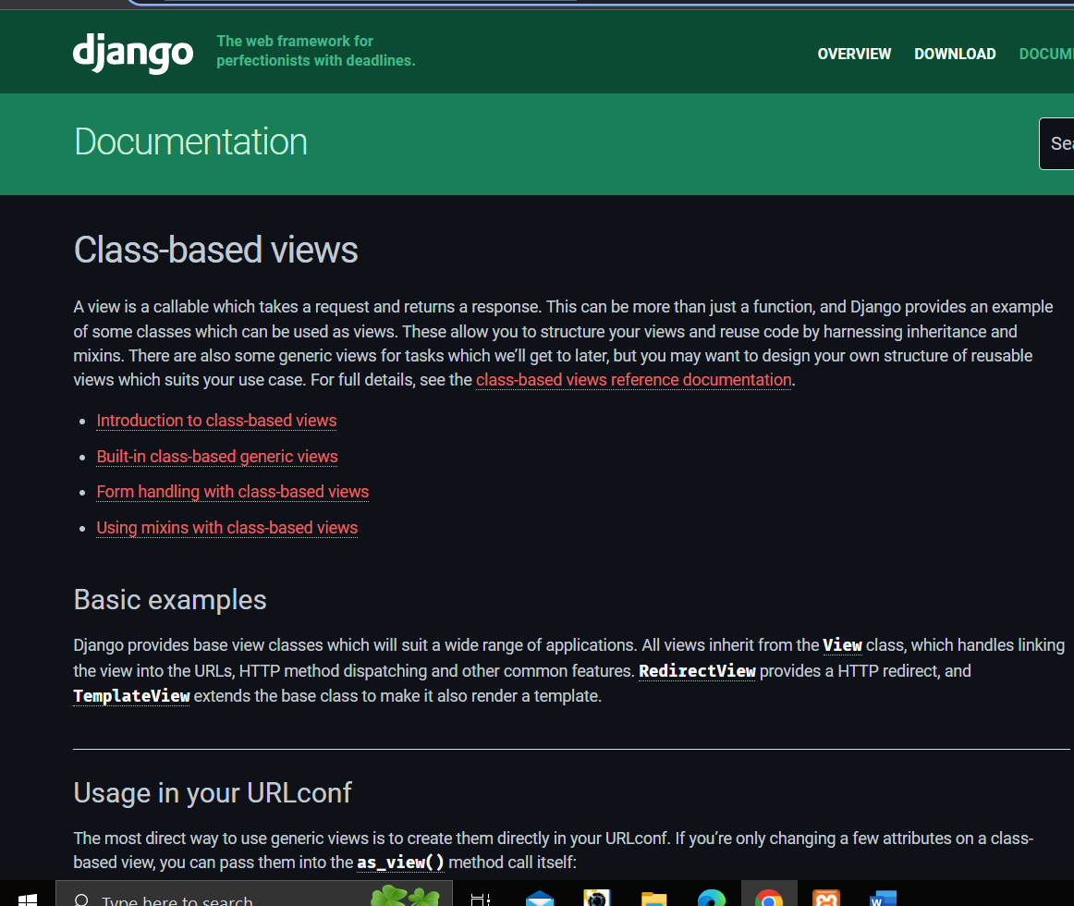

**API Integration:**

[**https://www.youtube.com/watch?v=D5nVnRjPrKA&t=1047s**](https://www.youtube.com/watch?v=D5nVnRjPrKA&t=1047s)

**Carousel Slider:**

[**https://www.youtube.com/watch?v=p3gFikowJVI&t=2s**](https://www.youtube.com/watch?v=p3gFikowJVI&t=2s)